Class X
Mathematics –Standard (041)
K V Karwar Sample Paper 2019-20

Max. Marks: 80 Duration : 3 hrs

General Instructions:
- All the questions are compulsory.
- The question paper consists of 40 questions divided into 4 sections A, B, C, and D.
- Section A comprises of 20 questions of 1 mark each. Section B comprises of 6 questions of 2 marks each. Section C comprises of 8 questions of 3 marks each. Section D comprises of 6 questions of 4 marks each.
- There is no overall choice. However, an internal choice has been provided in two questions of 1 mark each, two questions of 2 marks each, three questions of 3 marks each, and three questions of 4 marks each. You have to attempt only one of the alternatives in all such questions.
- Use of calculators is not permitted.

SECTION A
Q 1- Q 10 are multiple choice questions. Select the most appropriate answer from the given options.
1 | The decimal representation of will  ×  - terminate after 1 decimal place  - terminate after 2 decimal places  - terminate after 3 decimal places  - not terminate | 1

2 | Consider the following frequency distribution of the heights of 60 students of a class |  |  |  |  |  |  | 1
 | Height (in cm) | 150-155 | 155-160 | 160-165 | 165-170 | 170-175 | 175-180
 | No of students | 15 | 13 | 10 | 8 | 9 | 5
The upper limit of the median class in the given data is
- 165
- 155
- 160
- 170
3 | The LCM of smallest two digit composite number and smallest composite number is a) 12  - 4  - 20  - 44 |  |  |  |  |  |  | 1
4 | For which value(s) of , will the lines represented by the following pair of linear equations be parallel  3 − − 5 = 0 6 − 2 − = 0  - all real values except 10  - 10  - 5/2  - 1/2 |  |  |  |  |  |  | 1

5 | If triangle ABC is right angled at C, then the value of sec  - 0  - 1  - 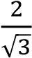  - not defined |  |  | (A+B) is | 1
6 | If +  a)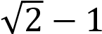  b)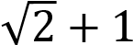  - 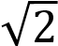  - 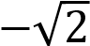 | = √2 , ( | ≠ 90°) then the value of | is | 1
7 | Given that  - 0°  - 90°  - 60°  - 30° | 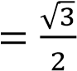 and | = 0, then the value of | − is | 1
8 | The point which divides the line segment joining the points (8, – 9) and (2, 3) in ratio 1 : 2 internally lies in the  - I quadrant  - II quadrant  - III quadrant  - IV quadrant |  |  |  | 1
9 | The distance of the point P (−3, −4) from the x-axis (in units) is a) 3  - −3  - 4  - 5 |  |  |  | 1

10 | If A( , 5)is the mid-point of the line segment joining the points Q (– 6, 7) and  R (– 2, 3), then the value of is  - −12  - −4  - 12  - −6 | 1
(Q 11- Q 15) Fill in the blanks

11 | The total surface area of the given solid figure is _______________  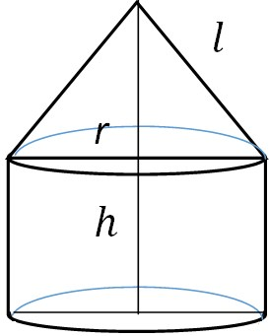 | 1
12 | If one root of the equation ( − 1) − 10 + 3 = 0 is the reciprocal of the other, then the value of is___________  OR  The graph of = ( ), where ( ) is a polynomial in variable x, is as follows:  Y  X  The number of zeroes of ( ) is _______________ | 1
13 | The perimeters of two similar triangles ∆ABC and ∆PQR are 35cm and 45cm respectively, then the ratio of the areas of the two triangles is______________ | 1

14 | Fill the two blanks in the sequence 2, ____ , 26, ____ so that the sequence forms an  A.P | 1
15 | A number is chosen at random from the numbers -5, -4, -3, -2, -1, 0, 1, 2, 3, 4, 5. Then the probability that square of this number is less than or equal to 1 is _____________ | 1
(Q 16- Q 20) Answer the following

16 | Write one rational and one irrational number lying between 0.25 and 0.32 | 1
17 | In the figure, if ACB = CDA, AC = 6 cm and AD = 3 cm, then find the length of AB  C  A B  D | 1
18 | If the angle between two tangents drawn from an external point ‘P’ to a circle of radius ‘r’ and centre O is 60⁰, then find the length of OP.  OR  If the radii of two concentric circles are 4 cm and 5 cm, then find the length of each chord of one circle which is tangent to the other circle. | 1
19 | If the first three terms of an A.P are b, c and 2b, then find the ratio of b and c | 1
20 | Find the value(s) of for which the quadratic equation + 2√2 + 18 = 0 has equal roots | 1
Section – B
21 | Find the number of natural numbers between 102 and 998 which are divisible by 2 and 5 both. | 2
22 | Prove that the rectangle circumscribing a circle is a square. | 2

23 | In the given figure, DEFG is a square and BAC = 90⁰. Show that FG²= BG x FC  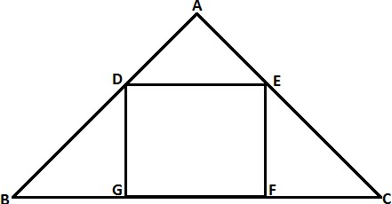  OR  In an equilateral triangle, prove that three times the square of one side is equal to four times the square of one of its altitudes. | 2
24 | ‘Skysails’ is that genre of engineering science that uses extensive utilization of wind energy to move a vessel in the sea water. The ‘Skysails’ technology allows the towing kite to gain a height of anything between 100 metres – 300 metres.  The sailing kite is made in such a way that it can be raised to its proper elevation and then brought back with the help of a ‘telescopic mast’ that enables the kite to be raised properly and effectively.  Based on the following figure related to sky sailing, answer the questions:  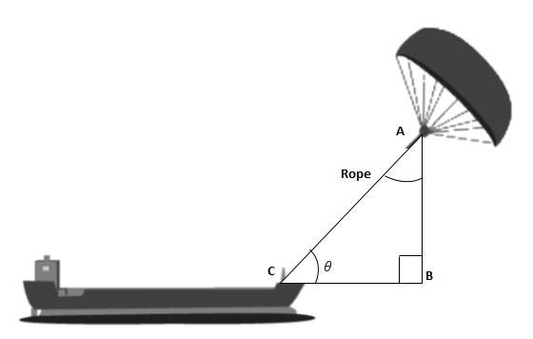  - In the given figure, if sin = cos (3 − 30 ), where and 3 − 30 are acute angles, then find the value of .  - What should be the length of the rope of the kite sail in order to pull the ship at the angle (calculated above) and be at a vertical height of 200 m? | 2

25 | Jayanti throws a pair of dice and records the product of the numbers appearing on the dice. Pihu throws 1 dice and records the squares the number that appears on it. Who has the better chance of getting the number 36? Justify?  OR  An integer is chosen between 70 and 100, Find the probability that it is  - a prime number  - divisible by 7 |  | 2
26 | Isha is 10 years old girl. On the result day, Isha and her father Suresh were very happy as she got first position in the class. While coming back to their home, Isha asked for a treat from her father as a reward for her success. They went to a juice shop and asked for two glasses of juice.  Aisha, a juice seller, was serving juice to her customers in two types of glasses.  Both the glasses had inner radius 3cm. The height of both the glasses was 10cm.  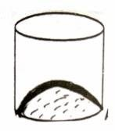  First type: A Glass with hemispherical raised bottom.  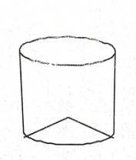  Second type: A glass with conical raised bottom of height 1.5 cm.  Isha insisted to have the juice in first type of glass and her father decided to have the juice in second type of glass. Out of the two, Isha or her father Suresh, who got more quantity of juice to drink and by how much? |  | 2
Section C

27 |  | Given that √5 is irrational, prove that 2√5 − 3is an irrational number.  OR  If HCF of 144 and 180 is expressed in the form 13m-16. Find the value of m. | 3

28 | If the sum of first m terms of an AP is the same as the sum of its first n terms, show that the sum of its first (m+n) terms is zero. | 3
29 | In the figure, ABCDE is a pentagon with BE||CD and BC||DE. BC is perpendicular to  CD. AB= 5cm, AE=5cm, BE= 7cm, BC= x-y and CD= x+y. If the perimeter of ABCDE is 27cm. find the value of x and y, given x, y ≠ 0.  A  - E  - D  OR  Solve the following system of equations:  21 47  + = 110  + = 162, , ≠ 0 | 3
30 | Obtain all the zeros of the polynomial x⁴+4x³-2x²-20x-15, if two of its zeroes are √5 and  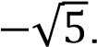 | 3
31 | Two friends Seema and Aditya work in the same office at Delhi. In the Christmas vacations, both decided to go to their hometowns represented by Town A and Town B respectively in the figure given below. Town A and Town B are connected by trains from the same station C (in the given figure)in Delhi.Based on the given situation, answer the following questions: | 3

- Who will travel more distance, Seema or Aditya, to reach to their hometown?
- Seema and Aditya planned to meet at a location D situated at a point D represented by the mid-point of the line joining the points represented by Town A and Town B. Find the coordinates of the point represented by the point D
- Find the area of the triangle formed by joining the points represented by A, B and C.
32 | If sin θ + cos θ = 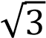 , then prove that tan θ + cot θ =1  OR  Evaluate:  ^{( ° ) ( ° )} + ( 30° + 90°) × ( 60° − 0°) ( ° )× ( ° ) | 3
33 | Sides of a right triangular field are 25m, 24m and 7m. At the three corners of the field, a cow, a buffalo and a horse are tied separately with ropes of 3.5 m each to graze in the field. Find the area of the field that cannot be grazed by these animals. | 3

34 |  | A TV reporter was given a task to prepare a report on the rainfall of the city Dispur of India in a particular year. After collecting the data, he analyzed the data and prepared a report on the rainfall of the city. Using this report, he drew the following graph for a particular time period of 66 days  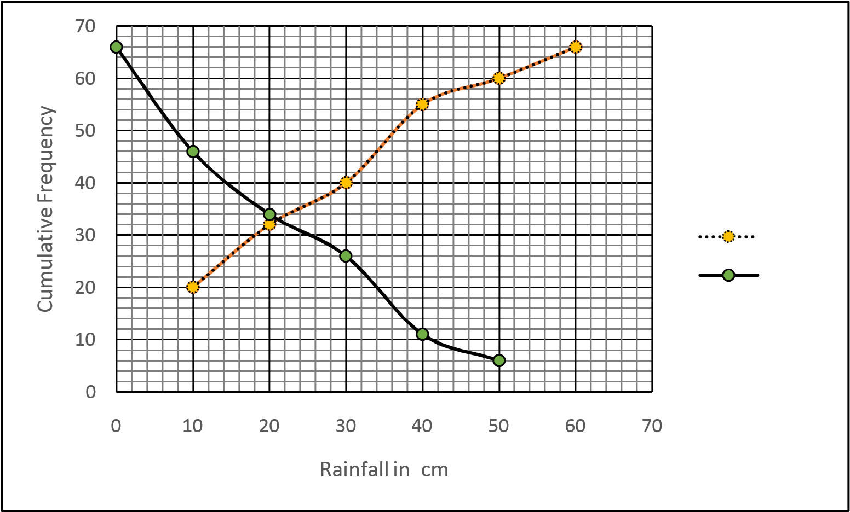  Based on the above graph, answer the following questions:  - Identify less than type ogive and more than type ogive from the given graph.  - Find the median rainfall of Dispur  - Obtain the Mode of the data if mean rainfall is 23.4cm | curve 1 curve 2 | 3
Section - D

35 | Draw a triangle ABC with side BC=6.5cm, ∠B=30°, ∠A =105°. Then construct another triangle whose sides are times the corresponding sides of the triangle ABC.  OR  Construct a pair of tangents to a circle of radius 3 cm which are inclined to each other at an angle of 60° |  |  | 4
36 | Prove that if a line is drawn parallel to one side of a triangle to intersect the other two sides in distinct points, then the other two sides are divided in the same ratio. |  |  | 4
37 | A train covers a distance of 360 km at a uniform speed. Had the speed been 5km/hour more, it would have taken 48 minutes less for the journey. Find the original speed of the train.  OR  Solve the following equation:  - = 3, ≠ 0, 2 |  |  | 4
38 | A petrol tank is in the form of a frustum of a cone of height 20 m with diameters of its lower and upper ends as 20 m and 50 m respectively. Find the cost of petrol which can fill the tank completely at the rate of Rs. 70 per litre. Also find the surface area of the tank.  OR  Water is flowing at the rate of 15km/hour through a pipe of diameter 14cm into a cuboidal pond which is 50m long and 44m wide. In what time will the level of water in the pond rise by 21cm? |  |  | 4
39 | The angle of elevation of an airplane from a point on the ground is 60⁰. After a flight of 30 seconds, the angle of elevation becomes 30⁰. If the airplane is flying at a constant height of 3000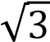 m, find the speed of the airplane. |  |  | 4
40 | Daily wages of 110 workers, obtained in a survey, are tabulated below:  Daily Wages (in Rs.) 100-120 120-140 140-160 160-180 180-200 200-220 220-240  Number of Workers 10 15 20 22 18 12 13  Compute the mean daily wages and modal daily wages of these workers. |  |  | 4

Class X
Mathematics (Standard)
SQP Marking Scheme (2019-20)

 | Section-A
1 | (c) 3 decimal places | 1
2 | (a) 165 | 1
3 | (c) 20 | 1
4 | (a) all real values except 10 | 1
5 | (d) not defined | 1
6 | 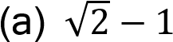 | 1
7 | (d) 30° | 1
8 | (d) IV quadrant | 1
9 | (c) 4 | 1
10 | (a) −12 | 1
11 | + 2 ℎ + | 1
12 | 4  OR  5 | 1  1
13 | 49 : 81 | 1
14 | 14, 38 | +
15 | 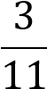 | 1
16 | Rational number= 0.30  Irrational number = 0.3010203040…  Or any other correct rational and irrational number
17 | ∆ACB~∆ADC (AA criterion)

⇒ =

∴ AB = 12 cm
18 | 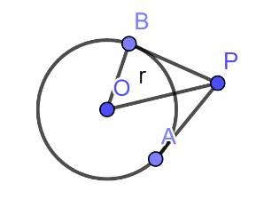  In ∆ , = sin 30°  ∴ = 2r  OR  Length of Tangent = 2 × √5 − 4 = 2 × 3 | = 6 | +
19 | , 2 are in A.P ⇒ =  ∴ ∶ = 2 ∶ 3
20 | = (2√2 ) − 4(1)(18) = 0 ⇒ k = ±3 |  | +
Section-B
21 | 110, 120, 130, … , 990  = 990 ⇒ 110 + (n − 1) × 10 = 990  ∴ = 89 |  | 1  1
22 | D R C  AP = AS, BP= BQ, CR= CQ and DR= DS  ⇒AP + BP + CR + DR = AS + BQ + CQ + DS S Q ⇒ AB + CD = AD + CB  But AB = CD and AD = CB  A P B ∴ AB = AD  Hence, ABCD is a square. |  | 1  1
23 | ∆ ~∆ and ∆ ~∆  ⇒ ∆ ~∆ (AA Criterion)  ⇒ = ⇒ GD × FE = GB × FC or = ×  OR |  | 1  1

 | A  B D C  ⊥ ∴ In ∆ , = +  ⇒ = + or 4 = 4 +  ⇒ 3 = 4 | 1
24 | - cos(90° − ) = cos(3 − 30°)  ⇒90° − = 3 − 30°⇒ = 30°  - = sin 30°  ∴ Length of rope = = 400 | 1  1
25 | For Jayanti,  Favourable outcome is (6,6) i.e, 1  Probability(getting the number 36) =  For Pihu,  Favourable outcome is 6 i.e, 1  Probability(getting the number 36) =  ∴ Pihu has the better chance.  OR  Total number of integers = 29  - Prob.(prime number) =  - Prob.(number divisible by 7) = | 1  1  1  1

26 | Capacity of first glass = −  = × 9(10 − 2) = 72  Capacity of second glass = − ℎ  = × 3 × 3(10 − 0.5) = 85.5  ∴Sureshgot more quantity of juice. | 1  1
Section - C

27 | Let us assume, to the contrary, that 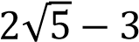 is a rational number  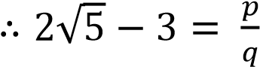 , where and are integers and ≠ ₀  ⇒ 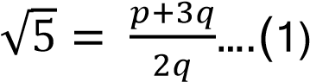  Since and are integers ∴ is a rational number 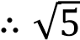 is a rational number which is a contradiction as 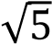 is an  irrational number  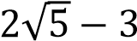  Hence our assumption is wrong and hence is an irrational number.  OR  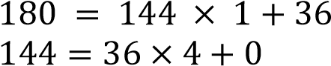  ∴ HCF(180, 144) = 36  36 = 13 − 16  Solving, we get = ₄ | 1  1  1  2  1
28 | = ⇒ [2 + ( − 1) ] = [2 + ( − 1) ]  ⇒ 2 ( − ) + ( − − + ) = 0  ⇒ (m − n)[2 + ( + − 1) ] = 0 or = 0 | 1  1  1
29 | + = 7 and 2( − ) + + + 5 + 5 = 27 ∴ + = 7 and 3 − = 17  Solving, we get, ₌ ₆ and ₌ ₁ | + 1  1

 | OR  Let = and =  ⇒ 21a + 47 b = 110 and 47 + 21 = 162  Adding and subtracting the two equations, we get  + = 4 and − = 2  Solving the above two equations, we get = ₃ and  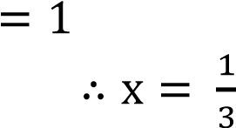  and = 1 |  | 1  1  1
30 | ( ) = + 4 − 2 − 20 − 15  − 5 is factor of ( )  ∴ ( ) = ( − 5)( + 4 + 3)  Or ( ) = ( − 5 )( + 3)( + 1)  So, all the zeroes of 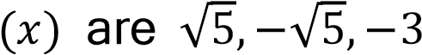 | and −1 | 2  1
31 | - A(1,7), B(4,2) C(-4,4)  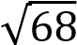  Distance travelled by Seema = 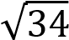 units  Distance travelled by Aditya = units  ∴ Aditya travels more distance  - Coordinates of D are , = ( , )  - ar(∆ABC) = [1(2 − 4) + 4(4 − 7) − 4(7 −  = 17 sq. units | 2)] | 1  1  1
32 | sin + cos = √3 ⇒ (sin + cos ) = 3 ⇒ 1 + 2 sin cos = 3 ⇒ sin cos = 1  ∴ tan + cot = + = 1 |  | 1  1  1

 | OR ( ° ))× ( ° )) + ( 30° + 90°) × ( 60° − 0°)  ( ° ( °  = (( °° ))× (( °° )) + (√3 + 1) × (√3 − 1)  = 1 + 2 = 3 | 2  1
33 | Required Area = Area of triangle – Area of 3 sectors  Area of Triangle = × 24 × 7 = 84  Area of three sectors = ° ×(sum of three angles of triangle)  × × × °  = ° = 19.25  × × ×  ∴ Required Area = 64.75 | 1  1  1
34 | - Curve 1 – Less than ogive, Curve2 – More than ogive  - Median Rainfall = 21 cm  - 3 Median = Mode + 2 mean  ∴ Mode = 16.2 cm | 1  1  1
Section-D
35 | Correct construction of given triangle  Correct construction of similar ∆with scale factor  OR  Correct construction of given circle  Correct construction of two tangents | 1  3  1  3
36 | For correct given, to prove, const. and figure  For correct proof | (4 ×  = 2)  2
37 | Let the original speed of the train be km/h  ∴ − =  ⇒ + 5 − 2250 = 0 | 2  1

 | ⇒ (x + 50)( − 45) = 0 ∴ = 45  Hence original speed of the train = 45km/h  OR  - = 3  =  ( )  3 - 6 = - 2  3 - 6 + 2 = 0  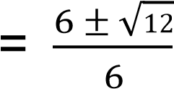  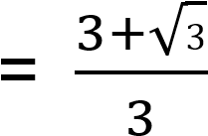  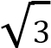  , |  |  |  |  |  | 1  1  1  1  1
38 | Capacity of tank = × 20 × (10 + 25 + 10 × 25)  = × 20 × 325 = × 20 × 325  Cost of petrol = × 20 × 325 × 70 = ₹1430000  Slant height = 20 + (25 − 10) = 25  Surface area of tank = × 25(10 + 25) = 2750  OR  Quantity of water flowing through pipe in 1 hour  = × × × 15000  Required time = 50 × 44 × ÷ ( × × × 15000)  = 2 hours |  |  |  |  |  | 1  1  1  2  2
39 | 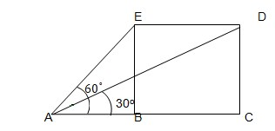  Correct figure  In ∆ , = tan 60°  ⇒ AB = 3000 m  In ∆ , = tan 30°  ⇒ AC = 9000 m  = − = 6000  ∴ Speed of aeroplane = / s = 200 / |  |  |  |  |  | 1  1  1
40 |  |  |  |  |  |  | 2  1  1
 |  | Daily  Wages(in Rs.) | Number of Workers( )
 |  | 100-120 | 10 | 110 | -3 | -30
 |  | 120-140 | 15 | 130 | -2 | -30
 |  | 140-160 | 20 | 150 | -1 | -20
 |  | 160-180 | 22 | 170 | 0 | 0
 |  | 180-200 | 18 | 190 | 1 | 18
 |  | 200-220 | 12 | 210 | 2 | 24
 |  | 220-240 | 13 | 230 | 3 | 39
 |  | Total | 110 |  |  | 1
Mean daily wages = 170 + × 20 = ₹170.19(approx.)
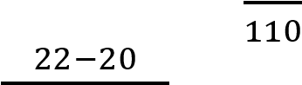
Mode = 160 + × 20 = ₹ 166.67(approx.)

