Class – X
Mathematics-Basic (241)
K V Karwar Practice paper 2019-20

Max. Marks: 80 Duration: 3 hrs.

General Instructions:

- All questions are compulsory
- The question paper consists of 40 questions divided into four sections A, B, C & D.
- Section A comprises of 20 questions of 1 mark each. Section B comprises of 6 questions of 2 marks each. Section C comprises of 8 questions of 3 marks each.
Section D comprises 6 questions of 4 marks each.
- There is no overall choice. However internal choices have been provided in two questions of 1 mark each, two questions of 2 marks each, three questions of 3 marks each and three questions of 4 marks each. You have to attempt only one of the alternatives in all such questions.
- Use of calculators is not permitted.

 | SECTION – A
Q 1- 10 are multiple choice questions. Select the most appropriate answer from the given options.

1. | HCF of 168 and 126 is  (a) 21 (b) 42 (c) 14 (d) 18 | 1
2. | Empirical relationship between the three measures of central tendency is | 1

(a) 2 Mean = 3 Median – Mode (b) 2 Mode = 3 Median – Mean
(c) Mode = 2 Mean – 3 Median (d) 3 Median = 2
Mode + Mean
3. | In the given figure, if TP and TQ are tangents to a circle with centre O, so that ∠POQ = 110°, then ∠PTQ is  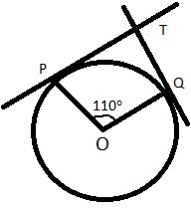  (a) 110° (b) 90°  (c) 80° (d) 70° | 1
4. | 325 can be expressed as a product of its primes as  (a) 5²×7 (b) 5²×13  (c) 5×13² (d) 2×3²×5² | 1
5. | One card is drawn from a well shuffled deck of 52 cards. The probability that it is black queen is  (a) (b) (c) (d) | 1
6. | The sum of the zeroes of the polynomial 2x²-8x +6 is  (a) - 3 (b) 3 (c) - 4  (d) 4 | 1
7. | Which of the following is the decimal expansion of an irrational number  (a) 4.561 (b) 0.12 (c) 5.010010001… (d) 6.03 | 1

8. | The following figure shows the graph of y = p(x), where p(x) is a polynomial in variable x. The number of zeroes of the polynomial p(x) is  (a) 1 (b) 2 (c)3 (d) 4  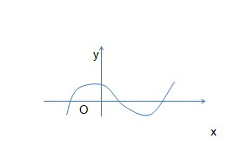 | 1
9. | The distance of the point P (3, - 4) from the origin is  (a) 7 units (b) 5 units (c)4 units  (d) 3 units | 1
10. | The mid point of the line segment joining the points (- 5, 7) and (- 1, 3) is  (a) (-3, 7) (b) (-3, 5) (c) (-1, 5)  (d) (5, -3) | 1
(11 – 15) Fill in the blanks:

11. | The point which divides the line segment joining the points A (0, 5) and  B (5, 0) internally in the ratio 2:3 is _____________ | 1
12. | The pair of lines represented by the equations 2x+y+3 = 0 and 4x+ky+6 = 0 will be parallel if value of k is ______.  OR  If the quadratic equation x² – 2x + k = 0 has equal roots, then value of k | 1

 | is ______.
13. | The value of sin 60 cos 30 + sin 30 cos 60 is______. | 1
14. | Value of cos 0°. Cos 30° .cos 45° . cos 60° . cos 90° is ___________. | 1
15. | The sides of two similar triangles are in the ratio 2:3, then the areas of these triangles are in the ratio ______________
(16 – 20) Answer the following :

16. | △PQR is right angled isosceles triangle, right angled at R. Find value of sin P.  OR  If 15 cot A = 8, then find value of cosec A. | 1
17. | If area of quadrant of a circle is 38.5 cm² then find its diameter (use π = ) | 1
18. | A dice is thrown once. Find the probability of getting a prime number. | 1
19. | In the given fig. If DE ‖ BC Find EC.  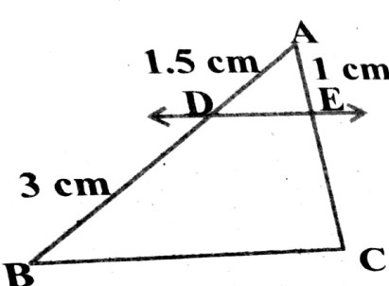 | 1

20. | Find the common difference of the A.P whose first term is 12 and fifth term is 0. | 1
 | SECTION – B
21. | If two coins are tossed simultaneously. Find the probability of getting 2 heads. | 2
22. | A lot of 25 bulbs contain 5 defective ones. One bulb is drawn at random from the lot. What is the probability that the bulb is good.  OR  Two dice are thrown simultaneously at random. Find the probability of getting a sum of eight. | 2
23. | Prove that the tangents drawn at the ends of a diameter of a circle are parallel. | 2
24. | Show that tan 48 tan 23 tan 42 tan 67 = 1.  OR  Evaluate cos 48 cos 42 − sin 48 sin 42 | 2
25. | Find the area of circle whose circumference is 22cm. | 2
26 | Read the following passage and answer the questions that follows:  A teacher told 10 students to write a polynomial on the black board.  Students wrote  - x ² + 2 6. x – 3  - 2x + 3 7. x⁴ + x² + 1  - x³+ x² + 1 8. x² + 2x + 1  - x³+ 2x² + 1 9. 2x³ – x² | 2

5. x² – 2x + 1 10. x⁴ – 1

- How many students wrote cubic polynomial
- Divide the polynomial (x² + 2x + 1) by ( x + 1).

 | SECTION C
27. | Find the zeroes of the quadratic polynomial x _{− 3x − 10} and verify the relationship between the zeroes and coefficient. | 3
28. | Draw a circle of radius 4 cm.From the point 7 cm away from its centre, construct the pair of tangents to the circle.  OR  Draw a line segment of length 8 cm and divide it in the ratio 2:3 | 3
29. | Following figure depicts a park where two opposite sides are parallel and left and right ends are semi-circular in shape. It has a 7m wide track for walking  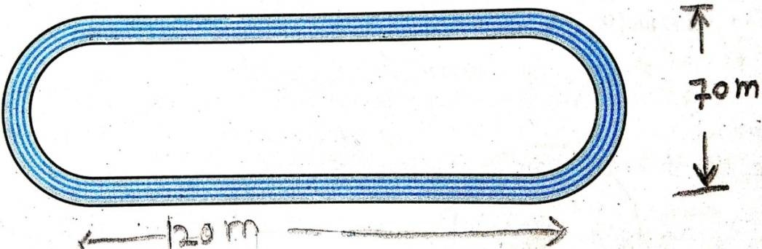  Two friends Seema and Meena went to the park. Meena said that area of the track is 4066m². Is she right? Explain. | 3
30. | Prove that ₌  OR  Prove that: = | 3

31. | Prove that 5 - √₃ is irrational, given that √₃ is irrational.  OR  An army contingent of 616 members is to march behind an army band of 32 members in a parade. The two groups are to march in the same number of columns. What is the maximum number of columns in which they can march ? | 3
32. | Prove that the lengths of tangents drawn from an external point to a circle are equal. | 3
33. | Read the following passage and answer the questions that follows:  In a class room, four students Sita, Gita, Rita and Anita are sitting at A(3,4), B(6,7), C(9,4), D(6,1) respectively. Then a new student Anjali joins the class  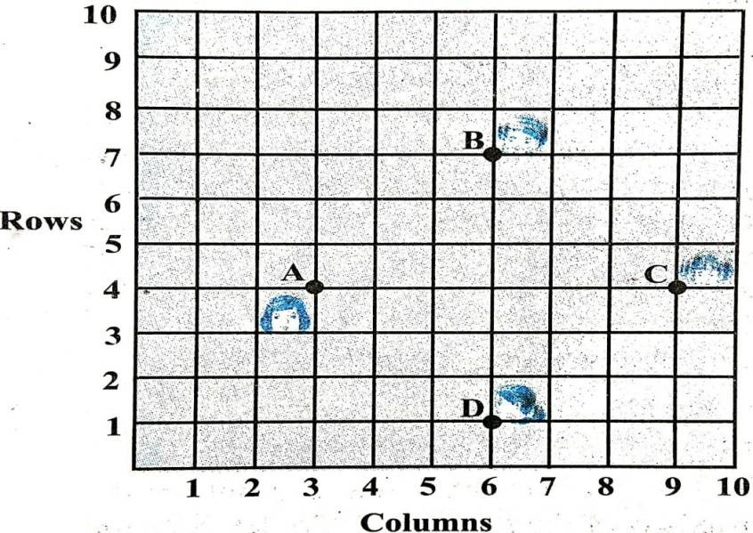 | 3
 | (i) Teacher tells Anjali to sit in the middle of the four students. Find the coordinates of the position where she can sit. | 1
 | (ii) Calculate the distance between Sita and Anita. | 1
 | (iii) Which two students are equidistant from Gita. | 1

34. | Solve 2x + 3y = 11 and x − 2y = −12 algebraically and hence find the value of ‘m’ for which y = mx + 3. | 3
 | SECTION D
35. | Find two consecutive positive integers sum of whose squares is 365. | 4
36. | If the sum of first 14 terms of an A.P. is 1050 and its first term is 10, find the 20 ^{th} term.  OR  The first term of an A.P. is 5, the last term is 45 and sum is 400. Find the number of terms and the common difference. | 4
37. | As observed from the top of a 75m high light house above the sea level, the angles of depression of two ships are 30^{O} and 45^{O} respectively If one ship is exactly behind the other on the same side of the light house and in the same straight line, find the distance between the two ships. (use 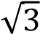 = 1.732) | 4
38. | If a line is drawn parallel to one side of a triangle to intersect the other two sides in distinct points, then prove that the other two sides are divided in the same ratio.  OR  State and prove the Pythagoras theorem. | 4
39. | A copper rod of diameter 1 cm and length 8 cm is drawn in to a wire of length 18 m of uniform thickness. Find the thickness of wire.  Or | 4
 | A metallic sphere of radius 4.2 cm is melted and recast into the shape of a cylinder of radius 6 cm. Find the height of the cylinder.
 |  | 4
40. | The following distribution gives the daily income of 50 workers of a factory  Daily income 400- 420 420-440 440-460 460-480 480-500  Number of workers 12 14 8 6 10  Convert this distribution to less than type of cumulative frequency distribution and draw its ogive.

Class – X
Mathematics-Basic (241)
Marking Scheme-SQP 2019-20

Max. Marks: 80 Duration: 3 hrs.
1. | (b) 42 | (1)
2. | (a)2 Mean = 3 Median – Mode | (1)
3. | (d)70° | (1)
4. | (b) 5²×13 | (1)
5. | (a) | (1)
6. | (d) 4 | (1)
7. | (c) 5.010010001… | (1)
8. | (c) 3 | (1)
9. | (b) 5 units | (1)
10. | (b) (- 3, 5) | (1)
11. | (2, 3) | (1)
12. | 2 OR 1 | (1)
13. | 1 | (1)
14. | 0 | (1)
15. | 4:9 | (1)
16. | Sin P = 1/ √₂ | (1)

OR

cosec A = 17/15
17. | Area of quadrant = × × r² = 38.5 (use π =  ⇒ r = 7cm  ∴ diameter = 14 cm | ) | 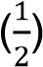  ( )
18. | 1  2 |  | 1
19. | = (By B.P.T.) 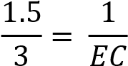  ∴ = 2 |  | ( )  ()
20. | A₅ = a₁ + 4d = 0 1² + 4d = 0 d = - 3 |  | ( )
SECTION – B
21. | P (Two Head) = |  | (1)  (1)
22. | Good bulbs = 25 – 5 = 20  P (good bulb) = =  OR  Of all those outcomes, the ones for which a + b = 8 are: 2+6, 3+5, 4+4, 5+3, 6+2 or 5 outcomes.  P = 5/36 |  | (1)  (1)  (1)  (1)

23. | A L B  C M D  ∠ = 90°  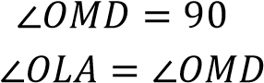  °  Which are alternate angles, hence AB _{∥ CD} | (1)  (1)
24. | LHS = tan 48° tan 23°tan 42°tan 67°  =Cot (90°-48°) cot (90°-23°) tan 42° tan 67°  =Cot 42° cot 67° tan 42° tan 67° =1  OR  =Cos 48°cos 42° – Sin 48° Sin 42°  =Sin (90° – 48°) sin (90°-42°) – Sin 48° Sin 42°  =Sin 42° Sin 48° – Sin 48° Sin 42° = 0 | (1)  (1)  (1)  (1)
25. | = Area of Circle= = cm² | (1)  (1)
26. | - 3 Students  = ⁽ ⁾ = + ₁ | (1)  (1)
SECTION – C

27. | x²-3x-10 = 0 x²-5x+2x-10 = 0 x(x-5) + 2(x-5)=0  (x-5) (x+2)=0  X = 5, -2  Sum of the roots = =  which is same as 5 - 2 = 3 product of the roots = = -10 which is same as 5x(-2) = -10  Hence verified | (3)
28. | Correct construction of given circle  Correct construction of two tangents  OR  Line of given length  Correct position of point which divides the line segment in the given ratio | (1)  (2)  (1) (2)
29. | Area of track = 120 × 70 + (35)² – [120 × 56 + (28)²]  = 120 × 14 + [(35)² - (28)²]  = 1680 + × 7 × 63  = 1680 + 1386  = 3066m²  Yes, Meena is wrong. | (1)  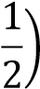  1  ()
30. | L.H.S. =  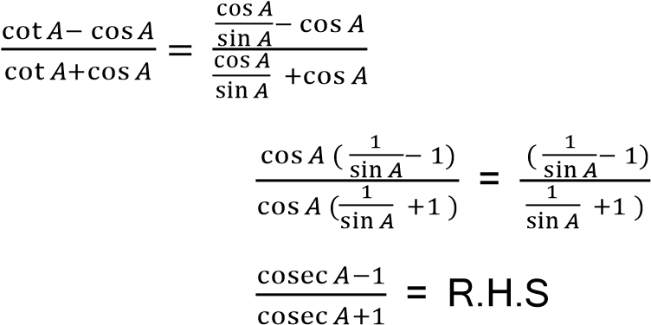  =  = | (1)  (1)

 | OR  L.H.S. =  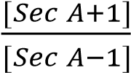  = 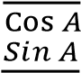 – =  = R.H.S |  | (1)  ( )  ( )  (1)  (1)
31. | Let us assume that 5 - 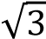 is a rational We can find co prime a & b ( b≠ ₀ ₎such that  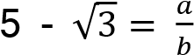  Therefore 5 - 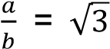  So we get 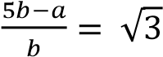  Since a & b are integers, we get is rational, and so 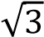  rational. But 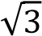 is an irrational number  Which contradicts our statement  is irrational  OR  616 =32 x 19+8  ⇒ r = 8≠0  32 = 8 x 4+0 ⇒ r = 0  The HCF of 32 and 616 is 8. | is | ( )  (1)  ( )  (1)  (2)  (1)
32. |  |  | (1)

 | 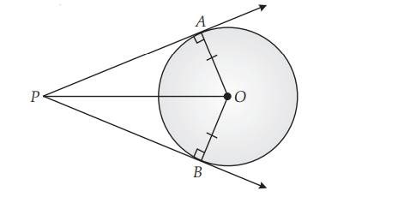  In ∆ ∆  ∠ = ∠ ( ℎ 90°)  = ( )  = ( )  ∆ ≅ ∆ (  Hence PA = PB (CPCT) |  | (1)  (1)
33. | (i) (6,4)  units (iii) Sita and Rita |  | (1)  (1)  (1)
34. | 2x + 3y = 11 ----(1) x-2y = -12 ----(2)  (2) ⇒ x = 2y -12 ----(3)  Substitute value of x from (3) in (1), we get  2(2y -12) +3y = 11  ⇒ 4y – 24 + 3 y = 11  ⇒7y = 35  ⇒y = 5  Substituting value of y = 5 in equation (3), we get  x= 2(5) - 12 = 10 - 12 = -2  Hence x = -2, y=5 is the required solution  Now 5= -2m +3  ⇒2m = 3-5 ⇒2m = -2 m = -1 |  | (1)  (1)  (1)
SECTION – D
35. | Let two consecutive positive integers be and | + 1 | ( )

 | ∴ + ( + 1) = 365  ⇒ + − 182 = 0  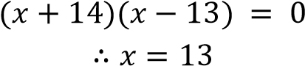  Hence two consecutive positive integers are 13 and 14 | (1 )  (1)  (1)
36. | Let common difference be  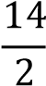  ⇒ [2(10) + ( − 1) ] = 1050  ⇒ = 10  = + 19  = 10 + 19 (10) = 200  OR  a=5  =  S = 400  ⇒ (5+45) = 400  50 ₌ ₈₀₀  = 16  also a = 45  5+15d = 45  15d=40 d=8/3 | (2)  (2)  (2)  (2)

37. | 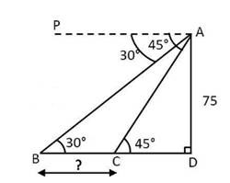  For correct fig  In∆ADC , tan 45 =  1 = ⇒ CD =75  In ∆ADB , tan 30 =  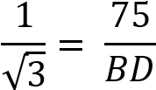  ⇒ BD = 75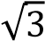  ⇒Distance between two ships = BC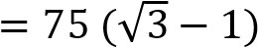 m  = 54.9 m | (1)  (1)  (1)  (1)
38. | For correct, Given, To prove, construction and Figure  For correct proof  OR  For correct statement, Given, To prove, Construction and Figure | - ×  = 2)  (2)  - ×  = 2 )

 | For correct proof |  |  |  |  |  | (1 )
39. | A.T. Q.  × 1800 = ×  ⇒ =  ⇒ r =  ∴ Thickness of wire = |  | × × 8  OR  = ℎ  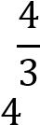  (4.2) = (6) ℎ  3  ⇒ℎ =  ∴ ℎ = 2 ∙ 744 |  |  |  | (2)  (1 )  ( )  (2)  (1 )  ( )
40.
 |  | Daily  Income |  | Number of workers | Cumulative Frequency
 |  | 400-420 |  | 12 | 12
 |  | 420-440 |  | 14 | 26
 |  | 440-460 |  | 8 | 34
 |  | 460-480 |  | 6 | 40
 |  | 480-500 |  | 10 | 50
 | Correct Table  Drawing an ogive with co-ordinates  (420,12),(440,26),(460,34),(480,40),(500,50) |  |  |  |  |  | (2)  (2)

